
COMSATS University Islamabad
Abbottabad, Pakistan

TrekPal

By

Student Name 1 CIIT/SP09-BCS-xxx/ATD
Student Name 2 CIIT/SP09-BCS-xxx/ATD

Supervisor
Supervisor Name

Bachelor of Science in Computer Science (20xx-20xx)

The candidate confirms that the work submitted is their own and appropriate
credit has been given where reference has been made to the work of others.


COMSATS University, Islamabad Pakistan

Project Name

A project presented to
COMSATS Institute of Information Technology, Islamabad

In partial fulfillment
of the requirement for the degree of

Bachelor of Science in Computer Science (20xx-20xx)

By

Student Name 1 CIIT/SP09-BCS-xxx/ATD
Student Name 2 CIIT/SP09-BCS-xxx/ATD

DECLARATION
We hereby declare that this software, neither whole nor as a part has been copied out from any source. It is further declared that we have developed this software and accompanied report entirely on the basis of our personal efforts. If any part of this project is proved to be copied out from any source or found to be reproduction of some other. We will stand by the consequences. No Portion of the work presented has been submitted of any application for any other degree or qualification of this or any other university or institute of learning.

Student Name 1 Student Name 2

--------------------------- ---------------------------

CERTIFICATE OF APPROVAL
It is to certify that the final year project of BS (CS) “Project title” was developed by
STUDENT 1 NAME (CIIT/FAXX-BCS/SE/TN-000) and STUDENT 2 NAME (CIIT/FAXX-BCS/SE/TN-000) under the supervision of “SUPERVISOR NAME” and co supervisor “CO-SUPERVISOR NAME” and that in (their/his/her) opinion; it is fully adequate, in scope and quality for the degree of Bachelors of Science in Computer Sciences.

---------------------------------------
Supervisor

---------------------------------------
External Examiner

---------------------------------------
Head of Department
(Department of Computer Science)

EXECUTIVE SUMMARY
In public places, there is often a need for monitoring people and different activities going on, which can be referred later for many reasons including security. Appointing humans for this task involves many problems such as increased employee hiring, accuracy problem, trust, no proof for later use, and also the fact that a human can remember things till a certain time limit. Talking about the current security system, they use dumb still cameras with a continuous recording facility ir-respective of the fact that any event may happen or not. Moreover they are usually pointing at a specific user defined locations so more than one cameras are required to cover the entire region.

To prevent all these problems from prevailing, the CSCS is developed. It is a surveillance system, which provides solution to many of these problems. It is a stand-alone application which doesn’t require any computer to operate. It monitors different situations using a camera which is able to rotate intelligently based on sensor messages and captures the scene in the form of video or photos later reference as well.

Customizable Surveillance Control System (CSCS) is a surveillance system that can be assigned a sensor type as in our case a heat sensor is used, it works accordingly, rotates the camera upon event detection and perform user defined actions like capturing video and stores them, for the future use.

It is an embedded system consisting of Linux fox kit with embedded a running server application also a camera, USB storage device and a sensor node base station is attached with fox kit. LAN communication is used by user to download the videos and to operate the system manually.

ACKNOWLEDGEMENT
All praise is to Almighty Allah who bestowed upon us a minute portion of His boundless knowledge by virtue of which we were able to accomplish this challenging task.

We are greatly indebted to our project supervisor “Dr. Majid Iqbal Khan” and our Co-Supervisor “Mr. Mukhtar Azeem”. Without their personal supervision, advice and valuable guidance, completion of this project would have been doubtful. We are deeply indebted to them for their encouragement and continual help during this work.

And we are also thankful to our parents and family who have been a constant source of encouragement for us and brought us the values of honesty & hard work.

Student Name 1 Student Name 2

--------------------------- ---------------------------

ABBREVIATIONS
SRS | Software Require Specification
PC | Personal Computer

TABLE OF CONTENTS
1 Introduction 11
1.1 Brief 11
1.2 Relevance to Course Modules 11
1.3 Project Background 11
1.4 Literature Review 11
1.5 Analysis from Literature Review (in the context of your project) 11
1.6 Methodology and Software Lifecycle for This Project 11
1.6.1 Rationale behind Selected Methodology 11
2 Problem Definition 12
2.1 Problem Statement 12
2.2 Deliverables and Development Requirements 12
2.3 Current System (if applicable to your project) 12
3 Requirement Analysis 13
3.1 Use Cases Diagram(s) 13
3.2 Detailed Use Case 13
3.3 Functional Requirements 13
3.4 Non-Functional Requirements 13
4 Design and Architecture 14
4.1 System Architecture 14
4.2 Data Representation [Diagram + Description] 14
4.3 Process Flow/Representation 14
4.4 Design Models [along with descriptions] 14
5 Implementation 15
5.1 Algorithm 15
5.2 External APIs 15
5.3 User Interface 15
6 Testing and Evaluation 16
6.1 Manual Testing 16
6.1.1 System testing 16
6.1.2 Unit Testing 16
6.1.3 Functional Testing 17
6.1.4 Integration Testing 17
6.2 Automated Testing: 18
Tools used: 18
7 Conclusion and Future Work 19
7.1 Conclusion 19
7.2 Future Work 19
8 References 20

LIST OF FIGURES

Fig 1.1 Block Diagram 8
Fig 2.1 Use Case Diagram 9

LIST OF TABLES

Table 1.1 Table1 8
Table 2.1 Table 2 9

- Introduction
This chapter presents an overview of the TrekPal system and establishes the context for the entire thesis. It introduces the purpose of the project, outlines the problem domain, and highlights the key objectives and scope of the proposed solution. The chapter also provides a brief understanding of the system’s core functionalities and identifies the stakeholders involved. By setting the foundation for the subsequent chapters, this section ensures a clear understanding of how the project is structured and what it aims to achieve.
TrekPal is a comprehensive travel management platform designed to simplify and modernize the trip planning process. In many regions, travel arrangements are often fragmented, requiring users to interact with multiple service providers for accommodation, transportation, and trip coordination. This lack of integration leads to inefficiencies, limited transparency, and reduced user confidence. TrekPal addresses these challenges by offering a unified digital ecosystem where travelers, travel agencies, and administrators interact within a single platform.
The system enables travelers to explore verified hotels and transportation options, create customized trip requests, and receive competitive bids from registered travel agencies. It further enhances the travel experience by supporting group trips and real time communication, allowing users to collaborate and coordinate effectively. Travel agencies are provided with tools to manage their services, respond to traveler requests, and optimize their offerings, while administrators ensure system reliability through verification and monitoring mechanisms.

  - Brief
A very brief introduction of project work, outcome of your work, tools, methodology used & highlights of discussions in various chapters of report. TrekPal is a full-stack, multi-platform travel management system designed to streamline and digitize the travel planning process by connecting travelers, travel agencies, and administrators within a unified digital ecosystem. The system enables travelers to create trip requests, receive competitive bids from travel agencies, compare offers, and confirm bookings in an efficient and structured manner. Travel agencies, on the other hand, can manage their hotels, vehicles, and travel packages while responding to traveler demands through a dynamic bidding mechanism. Administrators ensure platform integrity through verification, moderation, and approval of users and service providers.
The outcome of this project is a scalable and modular travel marketplace system consisting of a Flutter-based mobile application for travelers, React-based web portals for travel agencies and administrators, and a centralized backend built using Node.js, Express, and TypeScript. The backend is integrated with Supabase PostgreSQL for relational data management, Supabase Auth for authentication services, and Socket.IO for real-time communication features such as chat and bid notifications.
The development of TrekPal follows an Object-Oriented Design approach combined with a layered architectural pattern to ensure modularity, maintainability, and scalability. The Agile Scrum methodology is adopted for iterative development, allowing continuous improvement of features and system integration across multiple sprints.

  - Relevance to Course Modules
A The TrekPal project is strongly aligned with the core concepts and practical knowledge gained throughout the Bachelor of Science in Computer Science (BCS) program. It integrates multiple academic disciplines and demonstrates their real-world application in the development of a complete software system.
The course Software Engineering is directly reflected in the project through the use of Software Development Life Cycle practices, requirement analysis, system design, and documentation using SRS and SDD standards. The application of Agile Scrum methodology further demonstrates iterative development and project management concepts studied in this course.
From the Database Systems course, the project applies relational database design principles using Supabase PostgreSQL. Concepts such as normalization, entity-relationship modeling, foreign key relationships, and transaction management are implemented in the design of core modules including users, trip requests, bids, and bookings.
The Object Oriented Programming course is applied extensively in both backend and frontend development. The system is structured using classes, objects, encapsulation, and modular design. Key entities such as User, Agency, TripRequest, Bid, and Booking are modeled as object-oriented structures, ensuring maintainability and reusability.
Web Engineering concepts are implemented through the development of React-based web portals for travel agencies and administrators. This includes responsive UI design, component-based architecture, state management using Redux Toolkit, and secure API integration.
The Mobile Application Development course is reflected in the Flutter-based traveler application. It demonstrates cross-platform mobile development, state management using Provider, API integration, and handling of real-time features such as chat and notifications.
The Computer Networks course is applied through the implementation of RESTful APIs, client-server communication, and real-time communication using Socket.IO. Concepts such as HTTP protocols, request-response cycles, and WebSocket communication are utilized for efficient data exchange between system components.
Project Background
TrekPal is designed as a smart travel marketplace system that digitizes and unifies the entire travel planning workflow. Instead of traditional systems where users directly search and book hotels or transport services, TrekPal introduces a structured trip-based model. In this model, a traveler first creates a Trip Request that defines travel details such as destination, dates, budget, and number of travelers. Travel agencies then respond to these requests by submitting competitive bids that include bundled offers such as hotels, transportation, and additional services..
  - Literature Review
This The tourism and travel industry has undergone significant transformation with the emergence of digital technologies and online platforms. Traditional travel planning, which relied on physical travel agencies and manual coordination, has largely been replaced by Online Travel Agencies (OTAs) and digital booking platforms. Systems such as Booking.com, Airbnb, Expedia, and TripAdvisor have become global leaders by offering integrated solutions for hotel reservations, transportation booking, and travel planning services.
Modern research highlights that these platforms operate on a marketplace-based model where supply-side providers such as hotels and hosts are connected with demand-side users through centralized systems. Platforms like Airbnb use two-sided marketplace structures where hosts list accommodations and travelers search, compare, and book based on pricing, reviews, and availability. Similarly, Booking.com and Expedia provide large-scale aggregation of travel services, enabling users to compare multiple options in real time and make informed decisions. These systems heavily rely on ranking algorithms, user reviews, and recommendation systems to improve user experience and decision-making efficiency.
Recent advancements in travel technology show a strong shift toward mobile-based booking systems and artificial intelligence integration. Studies indicate that a significant portion of global travel bookings are now completed through mobile applications, highlighting the importance of mobile-first design in modern travel systems. Additionally, AI-powered travel planning tools are increasingly being integrated into major platforms to assist users in generating itineraries, suggesting destinations, and optimizing travel decisions based on preferences and constraints. However, research also shows that while AI improves convenience, it still requires validation due to limitations in accuracy and contextual understanding.
Another important trend in literature is the rise of personalized and dynamic travel planning systems. Instead of static booking models, modern research explores intelligent systems that can generate customized travel experiences based on user preferences, budget, and behavioral data. Some experimental systems introduce automated trip planning agents capable of using external data sources to construct travel itineraries, although their performance in real-world scenarios remains limited.
In addition, trust and safety have become major focus areas in digital travel platforms. Research emphasizes the importance of verification mechanisms, user authentication, and review systems to ensure reliability and reduce fraudulent activities. Many platforms now integrate identity verification and secure payment systems to enhance user confidence and platform credibility.

  - Analysis from Literature Review (in the context of your project)
This The literature review highlights that modern travel platforms such as Booking.com, Airbnb, Expedia, and TripAdvisor primarily operate on centralized marketplace models where users directly search, compare, and book travel services. These systems emphasize availability-based search, user reviews, and algorithm-driven recommendations to assist users in selecting suitable options. While these platforms provide efficiency and global accessibility, they largely follow a static booking approach where the traveler is responsible for identifying and selecting the best available option from predefined listings.
In contrast, TrekPal introduces a fundamentally different and more interactive approach by implementing a bid-based travel marketplace. Instead of users manually selecting from existing listings, travelers create structured Trip Requests that define their travel requirements such as destination, dates, budget, and number of passengers. Travel agencies then respond to these requests by submitting competitive bids that include customized packages combining hotels, transport, and additional services. This reverse marketplace model is not commonly observed in traditional travel systems and represents a key distinction from existing solutions identified in the literature
.
  - Methodology and Software Lifecycle for This Project
A The development of TrekPal follows an Object-Oriented Design (OOD) methodology combined with the Agile Scrum software development lifecycle. This combination is selected to support the complexity of the system, which consists of multiple interacting modules including travelers, travel agencies, administrators, booking workflows, bidding mechanisms, and real-time communication features.
The Object-Oriented approach is used to model the system in terms of real-world entities such as User, Agency, TripRequest, Bid, Booking, Hotel, and Vehicle. Each entity is represented as a class with well-defined attributes and behaviors, allowing the system to be modular, reusable, and easier to maintain.
For the software development process, the Agile Scrum model is adopted. This model divides the development into iterative cycles (sprints), where each sprint focuses on implementing specific features such as authentication, trip request management, bidding system, chat functionality, or booking workflow. Continuous feedback, testing, and incremental improvement are applied throughout the development lifecycle.
The combination of Object-Oriented Design and Agile methodology ensures that TrekPal is developed in a structured yet flexible manner, allowing changes and enhancements to be incorporated efficiently during the development process.

    - Rationale behind Selected Methodology
Why The selection of Object-Oriented Design and Agile Scrum methodology is based on the nature and requirements of the TrekPal system.
Object-Oriented Design is chosen because the system is heavily entity-driven. Real-world objects such as travelers, agencies, hotels, vehicles, and bookings can be directly mapped into classes, which simplifies system modeling and implementation. This approach improves modularity, code reusability, and scalability, which are essential for a system that involves multiple interconnected modules and complex relationships.
Agile Scrum is selected due to the iterative and evolving nature of the project. Since TrekPal includes multiple subsystems such as mobile application, web portals, backend services, and real-time communication modules, it is not practical to develop the entire system in a single linear phase. Agile allows the development team to implement features in small increments, test them continuously, and refine them based on feedback. This reduces development risks and ensures better alignment between requirements and final implementation.
Additionally, Agile supports continuous integration and testing, which is important for a system that depends on multiple technologies such as Flutter, React, Node.js, PostgreSQL, and Socket.IO.

- Problem Definition
This chapter discusses the precise problem to be solved. It should extend to include the outcome.

  - Problem Statement
P In the existing travel ecosystem, trip planning and management are highly fragmented and inefficient. Travelers typically rely on multiple independent platforms or traditional travel agencies to arrange accommodations, transportation, and travel packages. This process is often manual, time-consuming, and lacks transparency in pricing and service quality. In many cases, users are required to individually search for hotels and transport services, compare options manually, and coordinate separately with service providers, which leads to inconsistent experiences and increased effort.
Moreover, existing online travel platforms primarily follow a direct booking model where users select from predefined listings. These systems do not support dynamic interaction between travelers and service providers, nor do they provide structured negotiation or bidding mechanisms. As a result, users are limited to static pricing models and have minimal control over customized travel planning.
Another major issue is the lack of trust and verification mechanisms in many informal and semi-digital travel arrangements. Users often face uncertainty regarding the authenticity of service providers, quality of services, and reliability of bookings. Additionally, there is limited integration between different components of travel such as hotels, transport, and group coordination, which further reduces efficiency.
Therefore, there is a need for a centralized, intelligent, and interactive travel management system that can integrate all major travel services into a single platform. The system should enable travelers to define their travel requirements, allow service providers to compete through structured bidding, and ensure secure, verified, and transparent transactions. TrekPal is designed to address these challenges by introducing a unified travel marketplace with real-time communication, bid-based negotiation, and integrated booking management.

  - Deliverables and Development Requirements
The TrekPal project delivers a complete multi-platform travel management system consisting of a mobile application, web portals, and a backend server infrastructure. The final deliverables of the project are as follows:
The first deliverable is a Flutter-based mobile application for travelers. This application provides functionalities such as user registration, KYC verification, trip request creation, bid viewing and acceptance, hotel and transport browsing, group trip participation, real-time chat, booking management, and review submission.
The second deliverable is a React-based web portal for travel agencies. This portal enables agencies to register and manage their business profiles, upload and maintain hotel and vehicle listings, create travel packages, view trip requests, submit competitive bids, manage bookings, and communicate with travelers.
The third deliverable is a React-based admin dashboard. This module provides administrative control over the entire system, including verification and approval of travel agencies, hotels, vehicles, and travelers. It also includes content moderation, user management, and analytical reporting features.
The fourth deliverable is a backend system developed using Node.js, Express, and TypeScript. This backend provides RESTful APIs for all system operations, integrates with Supabase PostgreSQL for data storage, handles authentication using Supabase Auth and JWT, and supports real-time communication using Socket.IO.
In terms of development requirements, the system requires a cross-platform development environment supporting Flutter for mobile applications and React for web applications. The backend requires Node.js runtime with TypeScript support and a PostgreSQL-compatible database system. Additionally, real-time communication requires WebSocket support through Socket.IO, and secure authentication requires integration with Supabase services. Proper configuration for file storage, API security, and environment management is also required to ensure system stability and scalability.
Current System (if applicable to your project)
A brief description of an existing system.

The following figure is a sample figure, Figure 2.1. You are required to follow the same style of numbering and caption for the whole report.


Figure 2.1: Sample picture

The following table (Table 2.1) is sample table; you are required to follow the same style of numbering and caption for the whole report.
Table 2.1: Sample Table
Header 1 | Header 2 | Header 3
Text | Text | Text

The following list style is the sample to consistently follow in the whole report.
- List items 1
- List items 2

- Requirement Analysis

3.1 Use Case Diagram
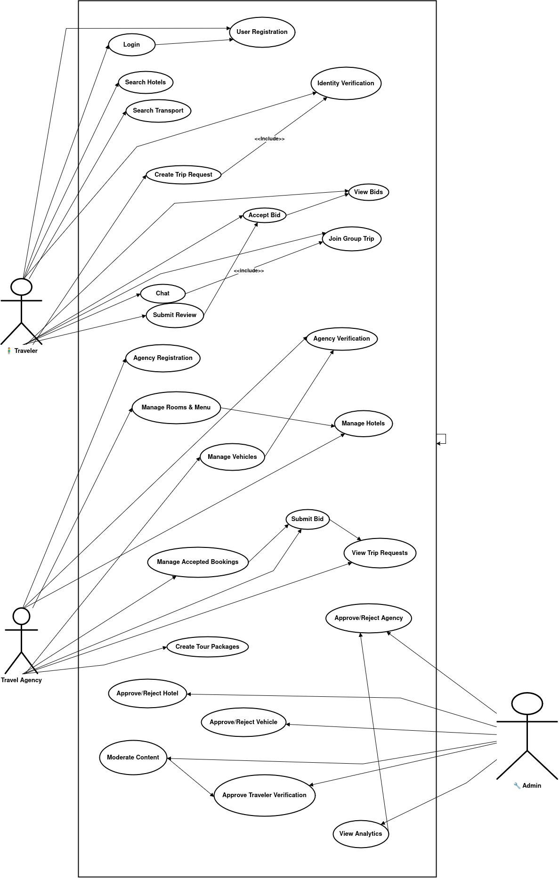
Actors

1. Traveler (User)
The primary end-user who:
- Creates Trip Requests
- Receives and compares bids
- Accepts bids which generate bookings
- Searches hotels and transport
- Books accommodations & vehicles
- Uses chat and group travel features
- Submits reviews

2. Travel Agency (Unified Business Actor)
A verified business account that:
- Manages hotels, rooms, menus
- Manages transport vehicles
- Views Trip Requests
- Submits bids to travelers
- Manages bookings from accepted bids
- Creates optional tour packages

3. Admin
Platform supervisor who:
- Verifies travelers & agencies
- Approves/rejects hotels and vehicles
- Moderates content
- Manages users
- Views system analytics

Use Cases Included in TrekPal
Traveler Use Cases
- UC-1 Register Account
- UC-2 Complete Verification
- UC-3 Search Hotels
- UC-4 Search Transport
- UC-5 Create Trip Request
- UC-6 View Bids
- UC-7 Accept Bid
- UC-8 Join Group Trip
- UC-9 Chat with Group Members
- UC-10 Submit Review
Travel Agency Use Cases
- UC-AG-01 Register Travel Agency
- UC-AG-02 Submit Agency Verification Documents
- UC-AG-03 Manage Hotels
- UC-AG-04 Manage Rooms & Menus
- UC-AG-05 Manage Vehicles
- UC-AG-06 View Trip Requests
- UC-AG-07 Submit Bid
- UC-AG-08 Manage Accepted Bookings
- UC-AG-09 Create Tour Packages (optional)

Admin Use Cases
- UC-ADM-01 Approve/Reject Travel Agency registration
- UC-ADM-02 Approve/Reject hotels submitted by agencies
- UC-ADM-03 Approve/Reject vehicles submitted by agencies
- UC-ADM-04 Approve traveler verification
- UC-ADM-05 Block/Unblock travelers or agencies
- UC-ADM-06 View system analytics
- UC-ADM-07 Moderate reviews and flagged content

3.2 Use Case Descriptions

UC-1: User Registration

Field | Description
Use Case ID | UC-1
Use Case Name | User Registration
Actor | Traveler
Description | The traveler creates a new account using email, phone number, or Google Sign-In.
Trigger | Traveler selects “Sign Up”.
Preconditions | None
Postconditions | A traveler account is created and can log in.
Main Flow | 1. Traveler enters required information.2. System validates inputs.3. System creates account.4. System sends confirmation/verification.
Alternative Flows | AF-1: Invalid input > system displays error.AF-2: Email already used > system requests different email.
Business Rules | BR-1: Email must be unique.

UC-2: Verification

Field | Description
Use Case ID | UC-2
Use Case Name | Identity Verification
Actor | Traveler
Description | Traveler uploads CNIC images to complete verification.
Trigger | Traveler selects “Verify Identity”.
Preconditions | Traveler is logged in.
Postconditions | Verification request submitted to Admin.
Main Flow | 1. Traveler uploads CNIC front/back.2. System stores documents.3. System notifies Admin.
Alternative Flows | AF-1: Upload failure > system requests retry.
Business Rules | BR-2: Verified identity required for certain booking operations.

UC-3: Hotel Search

Field | Description
Use Case ID | UC-3
Use Case Name | Search Hotels
Actor | Traveler
Description | Traveler searches available hotels.
Trigger | Traveler enters destination or opens hotel search.
Preconditions | Internet connection available.
Postconditions | List of matching hotels displayed.
Main Flow | 1. Traveler enters search query/filters.2. System retrieves approved hotels.3. System displays searchable list.
Alternative Flows | AF-1: No hotels found > “No results” message.
Business Rules | BR-3: Only verified agency hotels may appear in search.

UC-4: Search Transport

Field | Description
Use Case ID | UC-4
Use Case Name | Search Transport
Actor | Traveler
Description | Traveler searches available vehicles.
Trigger | Traveler opens Transport section.
Preconditions | Internet connection available.
Postconditions | Matching vehicles displayed.
Main Flow | 1. Traveler enters route/date.2. System retrieves vehicles.3. System displays list.
Alternative Flows | AF-1: No transport found.
Business Rules | BR-4: Vehicles must be approved by Admin.

UC-5: Create Trip Group

Field | Description
Use Case ID | UC-5
Use Case Name | Create Trip Request
Actor | Traveler
Description | Traveler creates a Trip Request specifying destination, dates, pax, and preferences.
Trigger | Traveler selects “Create Trip Request”.
Preconditions | Traveler identity verified.
Postconditions | Trip Request visible to Travel Agencies.
Main Flow | 1. Traveler enters details.2. System validates and saves.3. System notifies agencies.
Alternative Flows | AF-1: Invalid data.AF-2: Canceled before submission.
Business Rules | BR-5: Requests expire after a defined validity period.

UC-6: View Bids

Field | Description
Use Case ID | UC-6
Use Case Name | View Bids
Actor | Traveler
Description | Traveler views all bids submitted by agencies.
Trigger | Traveler opens Trip Request details.
Preconditions | Bids exist for the request.
Postconditions | Bids displayed and can be compared.
Main Flow | 1. Traveler opens request.2. System displays active bids.
Alternative Flows | AF-1: No bids yet.
Business Rules | BR-6: Only active bids shown.

UC-7: Accept Bid

Field | Description
Use Case ID | UC-7
Use Case Name | Accept Bid
Actor | Traveler
Description | Traveler accepts a bid, resulting in bookings.
Trigger | User clicks “Accept Bid.”
Preconditions | Trip Request active; bid available.
Postconditions | Bookings generated; agency notified.
Main Flow | 1. Traveler selects bid.2. System marks it accepted.3. System creates associated bookings.4. Notification sent to agency.
Alternative Flows | AF-1: Bid expired.AF-2: Bid withdrawn before acceptance.
Business Rules | BR-7: Accepted bids create binding bookings.

UC-8: Join Group Trip

Field | Description
Use Case ID | UC-8
Use Case Name | Join Group Trip
Actor | Traveler
Description | Traveler joins an existing group trip.
Trigger | Traveler taps “Join”.
Preconditions | Group has available seats.
Postconditions | User added to group.
Main Flow | 1. Join request sent.2. Group owner approves (or auto-approve).3. Traveler added.
Alternative Flows | AF-1: Group full.
Business Rules | BR-8: Some groups require verified users.

UC-9: Group Chat

Field | Description
Use Case ID | UC-9
Use Case Name | Group Chat
Actor | Traveler
Description | Travelers communicate in group chat.
Trigger | Traveler opens chat.
Preconditions | Traveler is trip group member.
Postconditions | Message delivered and stored.
Main Flow | 1. Traveler sends message.2. System broadcasts via WebSocket/FCM.3. Message stored.
Alternative Flows | AF-1: User offline > queued message.
Business Rules | BR-9: Message retention policy applies.

UC-10: Submit Review

Field | Description
Use Case ID | UC-10
Use Case Name | Submit Review
Actor | Traveler
Description | Traveler submits a review after a completed booking.
Trigger | Traveler selects “Write Review”.
Preconditions | Relevant hotel/vehicle booking completed.
Postconditions | Review published or held for moderation.
Main Flow | 1. Traveler writes review.2. System validates and saves.3. Review becomes visible.
Alternative Flows | AF-1: Violating content > flagged.
Business Rules | BR-10: One review per booking allowed.

Travel Agency Use Cases
UC-AG-01: Agency Registration
Field | Description
Use Case ID | UC-AG-01
Use Case Name | Agency Registration
Actor | Travel Agency
Description | The agency registers with business details and credentials.
Trigger | Agency selects “Register”.
Preconditions | None
Postconditions | Agency account created in pending-verification state.
Main Flow | 1. Agency enters details.2. Uploads business documents.3. System saves record.4. Admin notified.
Alternative Flows | AF-1: Missing documents.
Business Rules | BR-A1: Valid business documentation required.

UC-AG-02: Manage Hotels
Field | Description
Use Case ID | UC-AG-02
Use Case Name | Manage Hotels
Actor | Travel Agency
Description | Agency adds and updates hotels in its portfolio.
Trigger | Agency opens hotel management.
Preconditions | Agency verified.
Postconditions | Hotels stored (pending or approved).
Main Flow | 1. Add/edit hotel details.2. Upload images.3. Save listing.4. Admin approval if required.
Alternative Flows | AF-1: Missing mandatory fields.
Business Rules | BR-A2: Hotels require admin approval.

UC-AG-03: Manage Rooms & Menu
Field | Description
Use Case ID | UC-AG-03
Use Case Name | Manage Rooms & Menu
Actor | Travel Agency
Description | Add/edit/delete rooms and food menu.
Trigger | Agency opens room/menu section.
Preconditions | Agency owns hotel.
Postconditions | Room/menu data updated.
Main Flow | 1. Select hotel.2. Add/edit rooms/menus.3. Save updates.
Alternative Flows | AF-1: Invalid pricing or parameters.
Business Rules | BR-A3: Certain changes may require admin review.

UC-AG-04: Manage Vehicles
Field | Description
Use Case ID | UC-AG-04
Use Case Name | Manage Vehicles
Actor | Travel Agency
Description | Agency adds and updates transport vehicles.
Trigger | Agency opens vehicle section.
Preconditions | Agency verified.
Postconditions | Vehicle saved (pending/approved).
Main Flow | 1. Enter vehicle details.2. Upload documents.3. Save.4. Admin approval required.
Alternative Flows | AF-1: Missing registration documents.
Business Rules | BR-A4: Only approved vehicles are displayed.

UC-AG-05: View Trip Requests
Field | Description
Use Case ID | UC-AG-05
Use Case Name | View Trip Requests
Actor | Travel Agency
Description | Agency views Trip Requests posted by travelers.
Trigger | Agency opens Trip Request marketplace.
Preconditions | Active agency account.
Postconditions | Requests displayed.
Main Flow | 1. Agency opens marketplace.2. Filters requests.3. Views details.
Alternative Flows | AF-1: No matching requests.
Business Rules | BR-A5: Only requests within agency’s service area appear.

UC-AG-06: Submit Bid
Field | Description
Use Case ID | UC-AG-06
Use Case Name | Submit Bid
Actor | Travel Agency
Description | Agency submits a bid for a Trip Request.
Trigger | Agency selects “Place Bid”.
Preconditions | Trip Request active.
Postconditions | Bid stored and visible to traveler.
Main Flow | 1. Agency fills bid details.2. System validates.3. Bid posted.
Alternative Flows | AF-1: Withdraw bid before acceptance.AF-2: Update bid.
Business Rules | BR-A6: Bids must reference agency-owned assets.

UC-AG-07: Manage Accepted Bookings

Field | Description
Use Case ID | UC-AG-07
Use Case Name | Manage Accepted Bookings
Actor | Travel Agency
Description | Agency manages bookings created from accepted bids.
Trigger | Bid accepted by traveler.
Preconditions | Booking exists.
Postconditions | Booking status updated.
Main Flow | 1. Agency views booking list.2. Confirms hotel/vehicle reservations.3. Updates status.
Alternative Flows | AF-1: Cancel booking (per policy).
Business Rules | BR-A7: Booking updates must notify travelers.

Admin Use Cases

UC-ADM-01: Approve/Reject Agency Registration
Field | Description
Use Case ID | UC-ADM-01
Use Case Name | Approve/Reject Agency Registration
Actor | Admin
Description | Admin verifies agency documents and approves or rejects.
Trigger | Admin opens pending agencies.
Preconditions | Agency submitted registration.
Postconditions | Agency marked approved or rejected.
Main Flow | 1. Admin inspects documents.2. Approves or rejects.3. System notifies agency.
Alternative Flows | AF-1: Request additional documents.
Business Rules | BR-ADM1: Only approved agencies may operate.

UC-ADM-02: Approve/Reject Hotel
Field | Description
Use Case ID | UC-ADM-02
Use Case Name | Approve/Reject Hotel
Actor | Admin
Description | Admin reviews hotel listings.
Trigger | Admin opens pending hotels.
Preconditions | Hotel submitted by an agency.
Postconditions | Hotel status updated.
Main Flow | Review > Approve/Reject > Notify agency
Business Rules | BR-ADM2: Unapproved hotels hidden in search.

UC-ADM-03: Approve/Reject Vehicle
Field | Description
Use Case ID | UC-ADM-03
Use Case Name | Approve/Reject Vehicle
Actor | Admin
Description | Admin validates vehicle details.
Trigger | Admin opens pending vehicles.
Preconditions | Vehicle submitted by agency.
Postconditions | Vehicle approved or rejected.

UC-ADM-04: Approve Traveler Verification
Field | Description
Use Case ID | UC-ADM-04
Use Case Name | Approve Traveler Verification
Actor | Admin
Description | Admin verifies traveler identity documents.

UC-ADM-05: Moderate Content
Field | Description
Use Case ID | UC-ADM-05
Use Case Name | Moderate Content
Actor | Admin
Description | Admin handles flagged reviews, posts, or chats.

UC-ADM-06: View Analytics
Field | Description
Use Case ID | UC-ADM-06
Use Case Name | View Analytics
Actor | Admin
Description | Admin views system metrics and reports.

UC-ADM-07: Block/Unblock User or Agency
Field | Description
Use Case ID | UC-ADM-07
Use Case Name | Block/Unblock User or Agency
Actor | Admin
Description | Admin suspends or reinstates accounts.

4. Functional Requirements

Admin Portal Functional Requirements

FR-USER-01 — User Registration
Field | Description
Identifier | FR-USER-01
Title | User Registration
Requirement | The system shall allow travelers to create an account using email, phone number, or Google Sign-In.
Source | Traveler Use Cases (UC-1)
Rationale | Required for all personalized features.
Business Rules | Email/phone must be unique.
Dependencies | None
Priority | High

FR-USER-02 — Traveler Login

Field | Description
Identifier | FR-USER-02
Title | Traveler Login
Requirement | The system shall allow travelers to log in securely through Firebase Authentication.
Source | UC-1
Rationale | Enables authenticated access.
Business Rules | Tokens must be refreshed securely.
Dependencies | FR-USER-01
Priority | High

FR-USER-03 — Identity Verification

Field | Description
Identifier | FR-USER-03
Title | Identity Verification
Requirement | Travelers shall upload CNIC images for identity verification.
Source | UC-2
Rationale | Enhances user safety and compliance.
Business Rules | Verified users may access restricted features (e.g., bidding acceptance).
Dependencies | FR-USER-02
Priority | High

FR-USER-04 — Search Hotels

Field | Description
Identifier | FR-USER-04
Title | Search Hotels
Requirement | The system shall allow travelers to search hotels using filters such as location, rating, room type, and price.
Source | UC-3
Rationale | Core functionality of travel planning.
Business Rules | Only approved agency hotels appear in results.
Dependencies | Agency hotel data
Priority | High

FR-USER-05 — Search Transport

Field | Description
Identifier | FR-USER-05
Title | Search Transport
Requirement | The system shall allow travelers to search vehicles offered by Travel Agencies based on route, capacity, availability, and price.
Source | UC-4
Rationale | Provides travel mobility options.
Business Rules | Only approved vehicles appear.
Dependencies | Agency transport data
Priority | High

FR-USER-06 — Create Trip Request

Field | Description
Identifier | FR-USER-06
Title | Create Trip Request
Requirement | The system shall allow travelers to create Trip Requests including destination, dates, passengers, preferences, and budget.
Source | UC-5
Rationale | Enables agency bidding workflow.
Business Rules | Trip Requests must expire after a validity period.
Dependencies | FR-USER-03
Priority | High

FR-USER-07 — View Bids

Field | Description
Identifier | FR-USER-07
Title | View Bids
Requirement | The system shall display all bids submitted by agencies for a Trip Request.
Source | UC-6
Rationale | Traveler must compare offers.
Business Rules | Only active bids shown.
Dependencies | FR-AGENCY-07
Priority | High

FR-USER-08 — Accept Bid

Field | Description
Identifier | FR-USER-08
Title | Accept Bid
Requirement | The system shall allow the traveler to accept one bid, after which hotel and transport bookings are automatically created.
Source | UC-7
Rationale | Converts trip planning into confirmed bookings.
Business Rules | Accepted bid becomes binding according to platform policy.
Dependencies | FR-USER-06, FR-AGENCY-07
Priority | Critical

FR-USER-09 — Join Group Trip

Field | Description
Identifier | FR-USER-09
Title | Join Group Trip
Requirement | The system shall allow travelers to join group trips based on availability.
Source | UC-8
Rationale | Supports social travel features.
Business Rules | Some groups may require verified users.
Dependencies | Group module
Priority | Medium

FR-USER-10 — Submit Review

Field | Description
Identifier | FR-USER-10
Title | Submit Review
Requirement | The system shall allow travelers to submit reviews for hotels, vehicles, or agencies after trip completion.
Source | UC-10
Rationale | Enhances transparency and quality assurance.
Business Rules | One review per booking.
Dependencies | Completed booking
Priority | Medium

Travel Agency Functional Requirements

FR-AGENCY-01 — Agency Registration

Field | Description
Identifier | FR-AGENCY-01
Title | Agency Registration
Requirement | Agencies shall be able to register a business account by providing details and documents.
Source | UC-AG-01
Rationale | Required for agencies to participate.
Dependencies | None
Priority | High

FR-AGENCY-02 — Agency Verification

Field | Description
Identifier | FR-AGENCY-02
Title | Agency Verification
Requirement | Agencies shall upload business documents for admin approval.
Source | UC-AG-01 / UC-ADM-01
Rationale | Ensures platform trust & safety.
Dependencies | Admin module
Priority | High

FR-AGENCY-03 — Manage Hotels

Field | Description
Identifier | FR-AGENCY-03
Title | Manage Hotels
Requirement | Agencies shall add, update, and delete hotels.
Source | UC-AG-02
Rationale | Core service offering.
Business Rules | Hotels require admin approval before appearing publicly.
Dependencies | FR-AGENCY-02
Priority | High

FR-AGENCY-04 — Manage Rooms & Food Menus

Field | Description
Identifier | FR-AGENCY-04
Title | Manage Rooms & Menus
Requirement | Agencies shall manage room details, prices, availability, and food menus.
Source | UC-AG-03
Rationale | Required for accurate hotel listings.
Dependencies | FR-AGENCY-03
Priority | High

FR-AGENCY-05 — Manage Vehicles

Field | Description
Identifier | FR-AGENCY-05
Title | Manage Vehicles
Requirement | Agencies shall add and manage transport vehicles.
Source | UC-AG-04
Rationale | Provides transport services.
Business Rules | Vehicles require admin approval.
Dependencies | FR-AGENCY-02
Priority | High

FR-AGENCY-06 — Manage Vehicle Availability

Field | Description
Identifier | FR-AGENCY-06
Title | Manage Vehicle Availability
Requirement | Agencies shall define availability and pricing per date.
Source | UC-AG-04
Rationale | Enables accurate bookings & bidding.
Dependencies | FR-AGENCY-05
Priority | Medium

FR-AGENCY-07 — View Trip Requests

Field | Description
Identifier | FR-AGENCY-07
Title | View Trip Requests
Requirement | Agencies shall view active Trip Requests submitted by travelers.
Source | UC-AG-05
Rationale | Required for bidding process.
Dependencies | FR-USER-06
Priority | High

FR-AGENCY-08 — Submit Bid

Field | Description
Identifier | FR-AGENCY-08
Title | Submit Bid
Requirement | Agencies shall submit a bid including price, hotel, vehicle, and services.
Source | UC-AG-06
Rationale | Enables competitive marketplace.
Business Rules | Bids must reference agency-owned, approved assets.
Dependencies | FR-AGENCY-03, FR-AGENCY-05
Priority | Critical

FR-AGENCY-09 — Manage Accepted Bookings

Field | Description
Identifier | FR-AGENCY-09
Title | Manage Accepted Bookings
Requirement | Agencies shall manage bookings created from accepted bids.
Source | UC-AG-07
Rationale | Ensures fulfillment of hotel/transport services.
Dependencies | Accepted bid
Priority | High

FR-AGENCY-10 — Create Tour Packages

Field | Description
Identifier | FR-AGENCY-10
Title | Create Tour Packages
Requirement | Agencies shall create optional tour packages with itinerary and pricing.
Source | UC-AG-10
Rationale | Additional service offering.
Dependencies | FR-AGENCY-02
Priority | Medium

Admin Functional Requirements

FR-ADMIN-01 — Approve/Reject Agency Registration

Field | Description
Identifier | FR-ADMIN-01
Title | Approve/Reject Agency Registration
Requirement | Admin shall approve or reject Travel Agency registrations.
Source | UC-ADM-01
Rationale | Ensures only legitimate businesses operate.
Dependencies | FR-AGENCY-01
Priority | High

FR-ADMIN-02 — Approve/Reject Hotels

Field | Description
Identifier | FR-ADMIN-02
Title | Approve/Reject Hotels
Requirement | Admin shall review hotels submitted by agencies and approve or reject them.
Source | UC-ADM-02
Rationale | Ensures quality and trust.
Dependencies | FR-AGENCY-03
Priority | High

FR-ADMIN-03 — Approve/Reject Vehicles

Field | Description
Identifier | FR-ADMIN-03
Title | Approve/Reject Vehicles
Requirement | Admin shall verify all vehicle submissions.
Source | UC-ADM-03
Rationale | Ensures safe and verified transport options.
Dependencies | FR-AGENCY-05
Priority | High

FR-ADMIN-04 — Approve Traveler Verification

Field | Description
Identifier | FR-ADMIN-04
Title | Approve Traveler Verification
Requirement | Admin shall verify traveler identity documents.
Source | UC-ADM-04
Rationale | Increases user trust.
Priority | High

FR-ADMIN-05 — Content Moderation

Field | Description
Identifier | FR-ADMIN-05
Title | Moderate Content
Requirement | Admin shall review and manage reported reviews, chats, or posts.
Source | UC-ADM-05
Rationale | Ensures platform safety.
Priority | Medium

FR-ADMIN-06 — View Analytics

Field | Description
Identifier | FR-ADMIN-06
Title | View Analytics
Requirement | Admin shall view dashboards for bookings, trips, revenue, and system usage.
Source | UC-ADM-06
Rationale | Supports decision-making.
Priority | Medium

FR-ADMIN-07 — Block/Unblock Accounts

Field | Description
Identifier | FR-ADMIN-07
Title | Block/Unblock Accounts
Requirement | Admin shall be able to block or unblock travelers or agencies.
Source | UC-ADM-07
Rationale | Protects system integrity.
Priority | High

5. Non-Functional Requirements
Non-functional requirements describe the quality attributes of the TrekPal system.

5.1 Usability Requirements
NFR-USE-01 — Simple & Intuitive UI
The system shall provide a clean and easy-to-navigate interface on both mobile and web.
NFR-USE-02 — Clear Feedback
Users shall receive meaningful success/error messages.
NFR-USE-03 — Easy Onboarding
Registration and login shall be completed within a few simple steps.

5.2 Reliability Requirements
NFR-REL-01 — High Availability
The system shall maintain 99% uptime.
NFR-REL-02 — Prevent Double Booking
The system shall ensure no hotel room or vehicle can be double-booked.
NFR-REL-03 — Data Backup
Database backups shall occur at least once daily.

5.3 Performance Requirements
NFR-PERF-01 — Fast Response
Search results and main screens shall load within 2–3 seconds.
NFR-PERF-02 — Real-Time Chat
Chat messages shall deliver with a delay of less than 300 ms.
NFR-PERF-03 — Scalable User Load
The system shall support large numbers of active users without performance degradation.

- Design and Architecture
The following parts of Software Design Description (SDD) report should be included in this chapter.

  - System Architecture
The overall system operates through four major subsystems:

1. Traveler Mobile Application
The mobile app enables travelers to register, verify identity, browse hotels, search transport, create Trip Requests, compare bids from agencies, join or create group trips, chat with members, and review completed trips. It serves as the core user-facing interface and interacts heavily with backend services for bookings, profiles, and notifications.

2. Travel Agency Web Portal
This portal allows agencies to register their business, upload verification documents, manage multiple hotels and vehicles, create tour packages, and submit competitive bids for Trip Requests. The portal replaces separate hotel and transport owner systems and consolidates all commercial activities into one dashboard.

3. Admin Dashboard
The admin portal provides monitoring and verification capabilities. Admins approve or reject agency registrations, hotel listings, and vehicles, verify traveler CNIC submissions, moderate flagged content, and view analytical dashboards. This ensures a safe, trustworthy, and well-regulated environment.

4. Backend System
The backend is responsible for authentication, data storage, business logic, notifications, and search operations. It integrates Firebase Authentication for secure login, PostgreSQL for storing structured data, and Google Maps API for destination and location services. Real-time chat and onboarding updates are handled through WebSocket or Firebase Cloud Messaging.

Architectural design

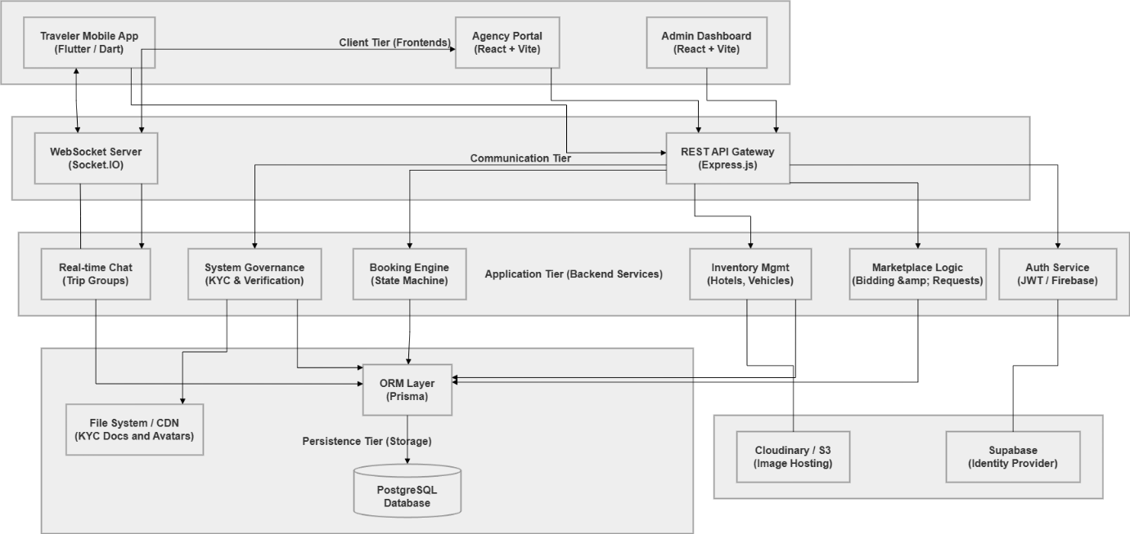

  - Data Representation [Diagram + Description]
Class Diagram
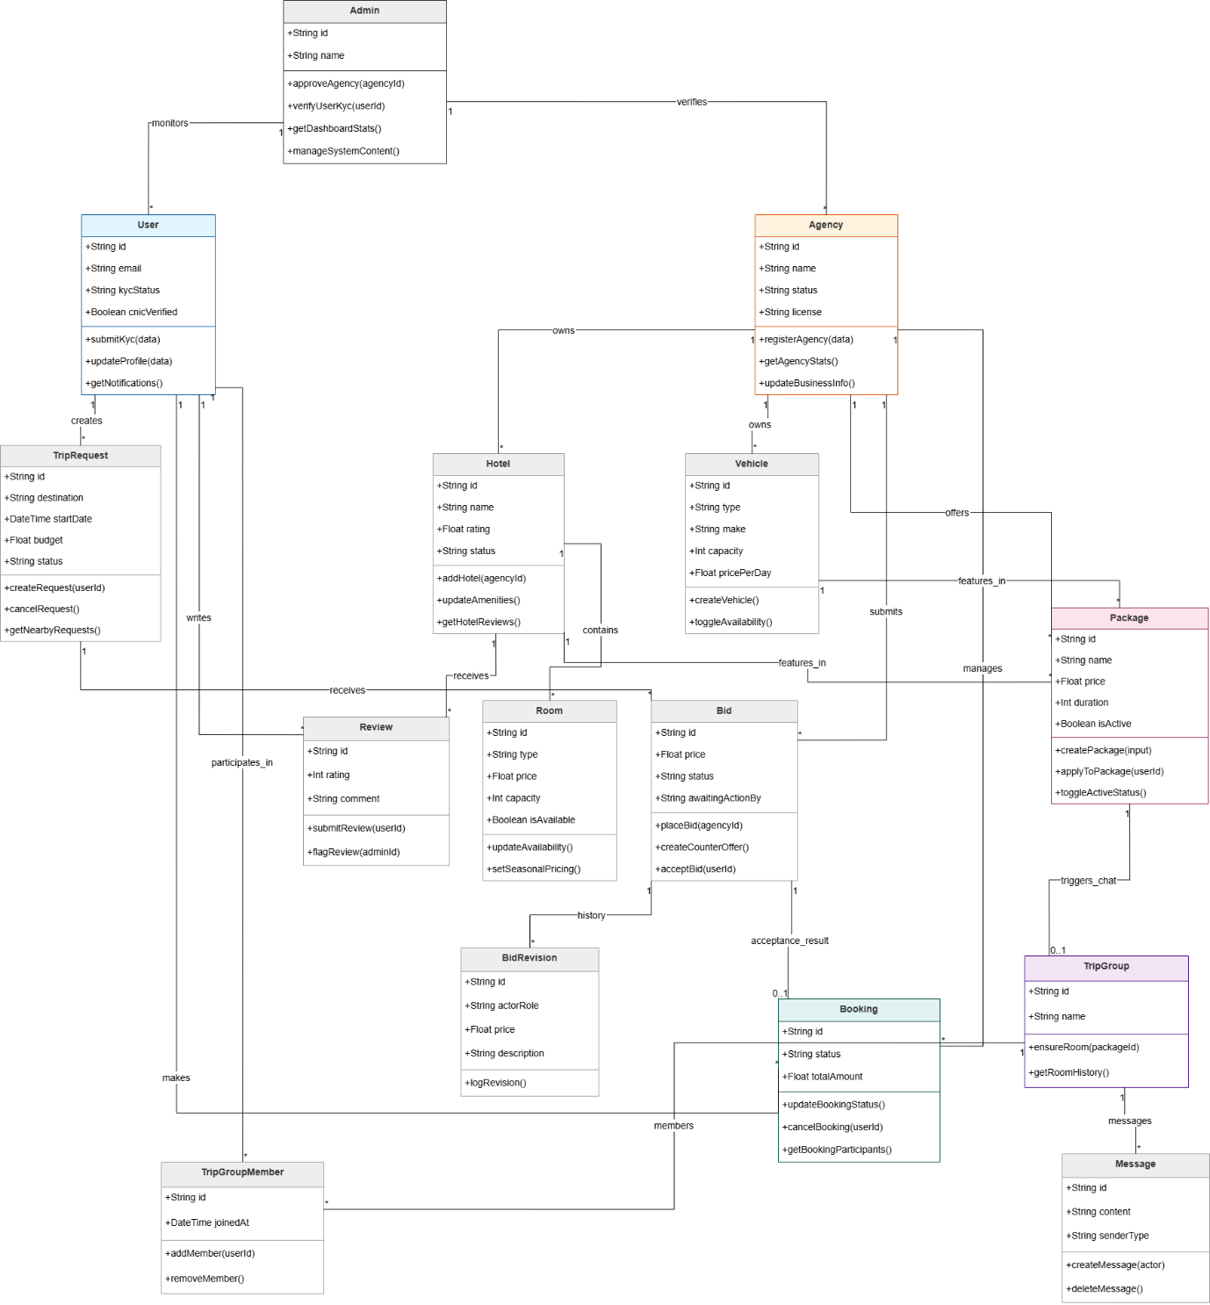

Sequence Diagram
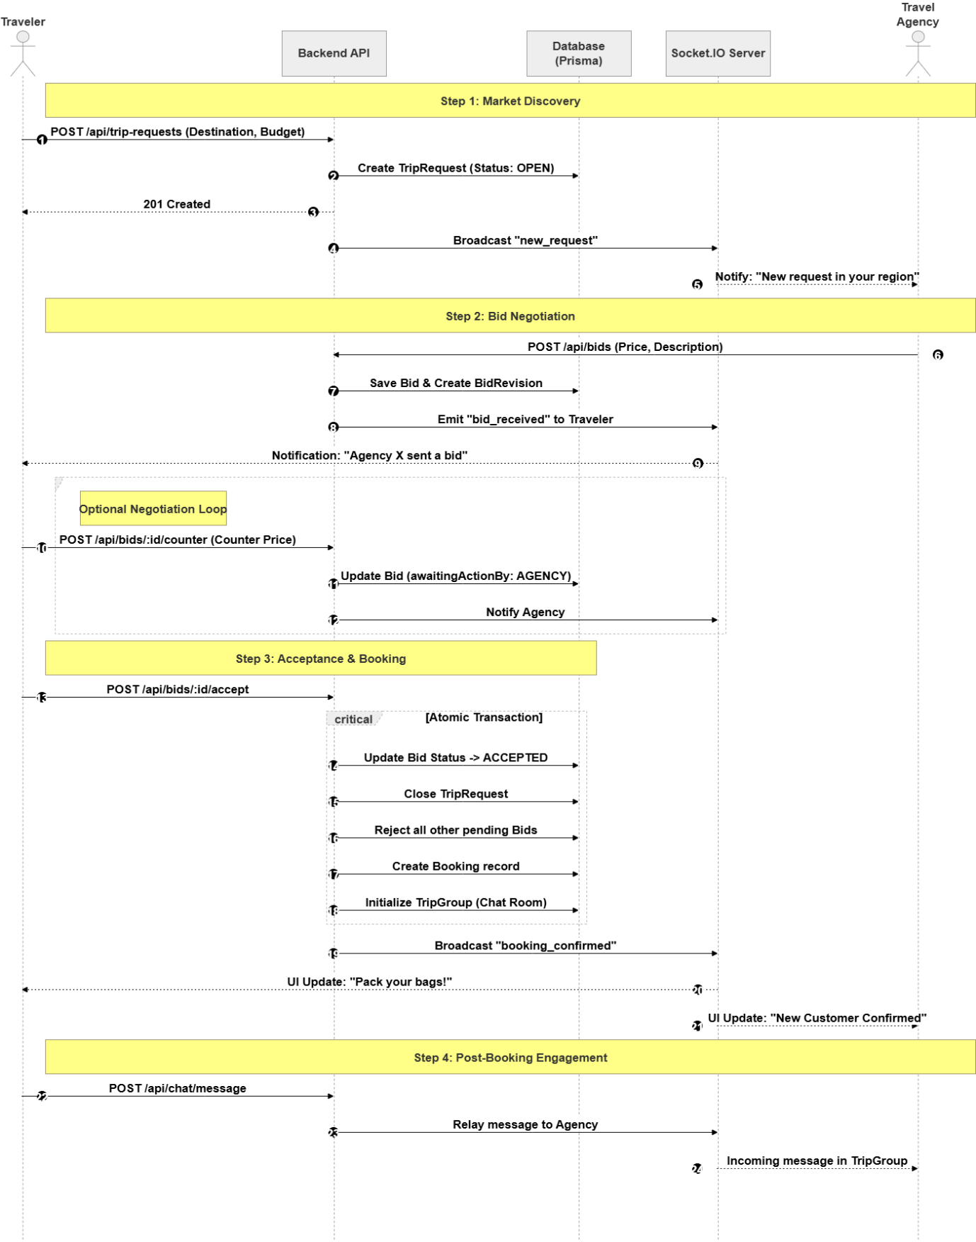

State Transition
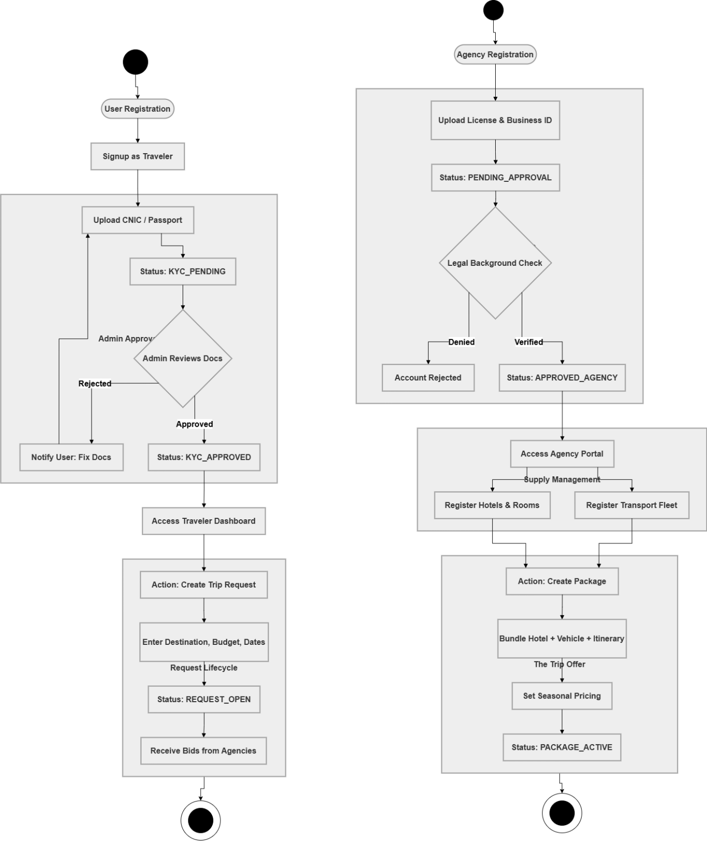

ERD

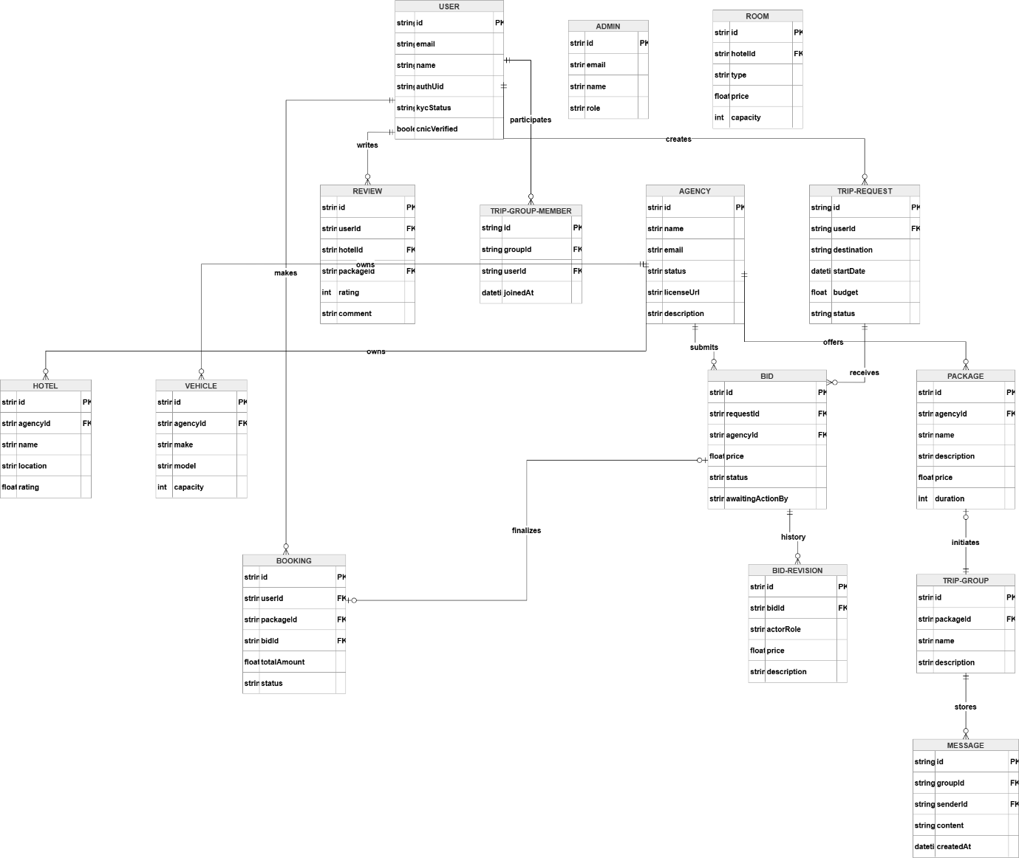
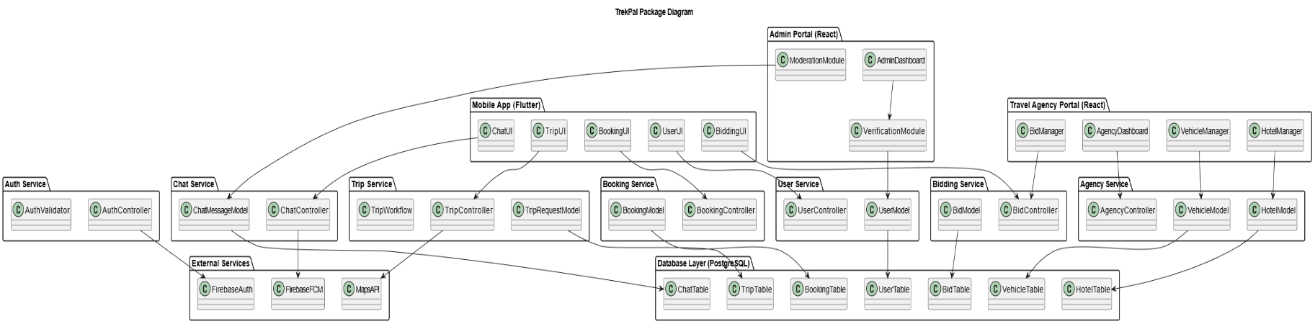
Package Diagram

  - Process Flow/Representation
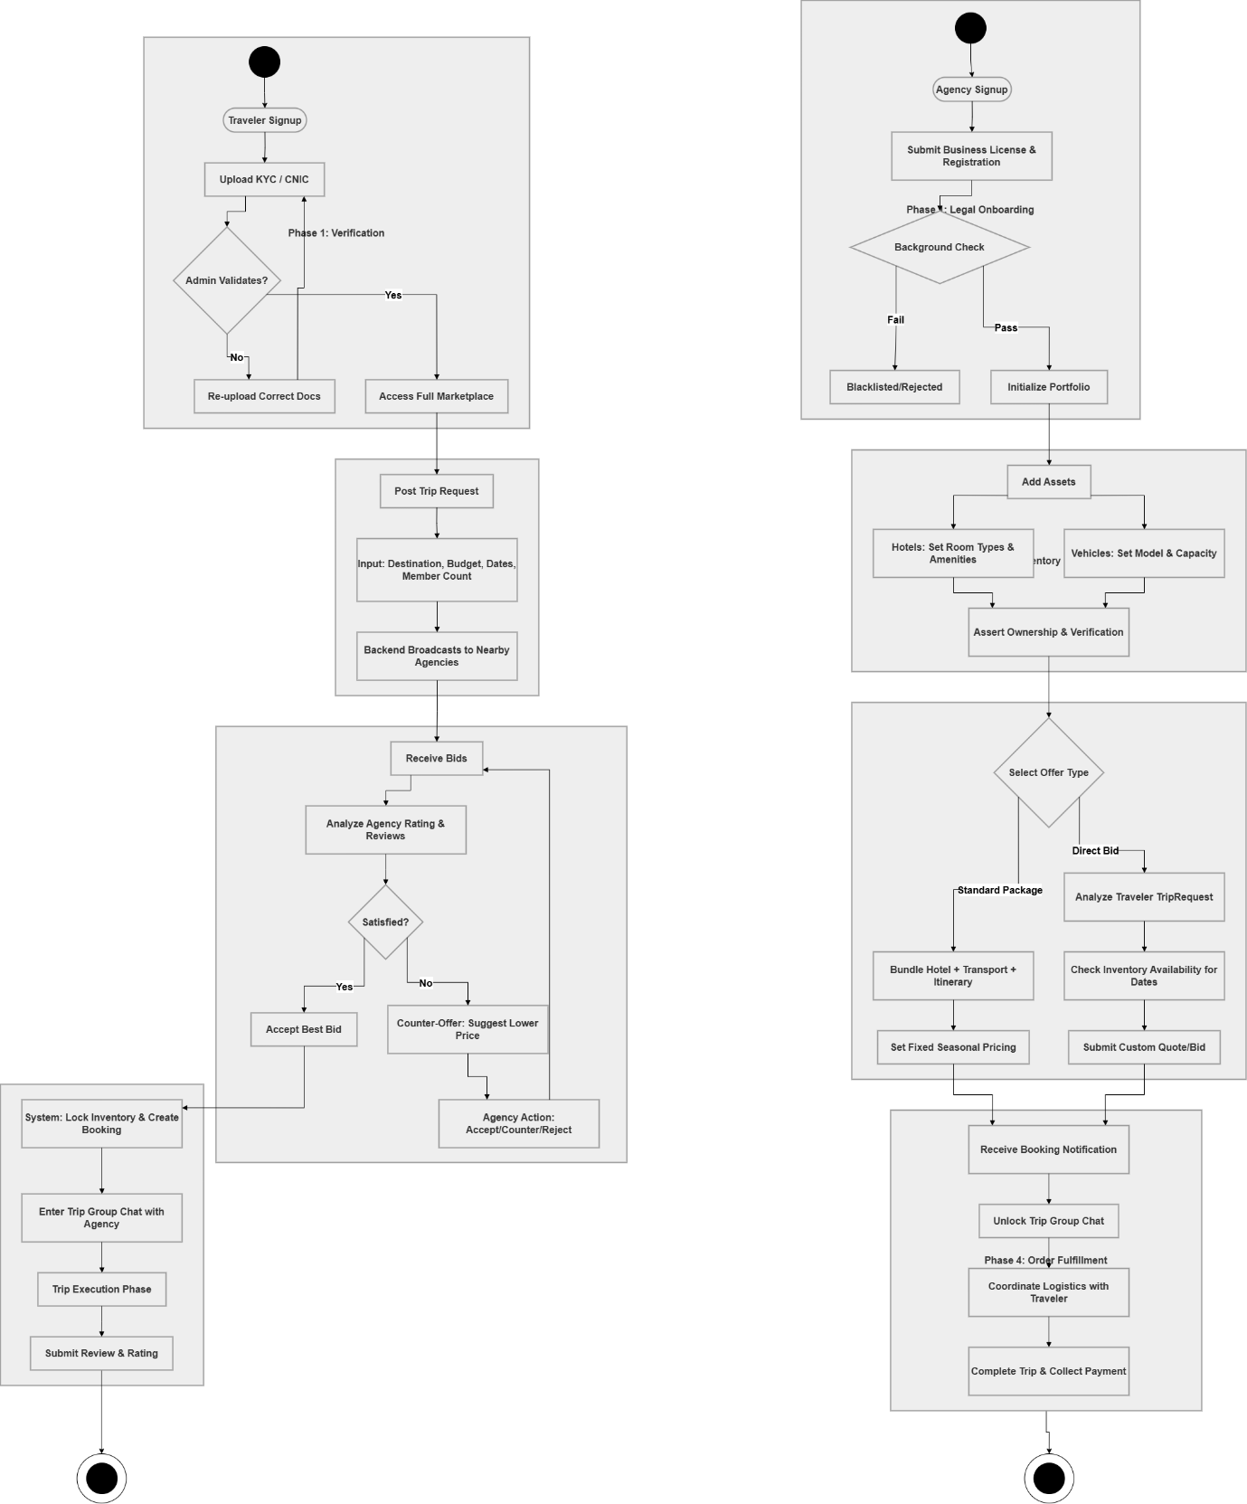

  - Design Models [along with descriptions]

Data design
The data design of TrekPal defines how the system’s information domain is transformed into structured data models that support the functional and non-functional requirements. Since TrekPal uses an object-oriented architecture along with a relational database (PostgreSQL), all major system entities are represented as classes in the backend and tables in the database.
The purpose of the data design is to ensure:
- Efficient storage of user, trip, and booking information
- Normalized relational structure for consistency
- Scalable representation of hotels, vehicles, bids, and chat data
- Easy mapping between backend service objects and database tables
- Compatibility with ORM tools (Prisma / Sequelize)

5.1 Data Organization & Storage
Database Technology: PostgreSQL
All persistent data is stored in PostgreSQL due to its reliability, ACID compliance, relational structure, and support for transactions (important for booking consistency).
Data Storage Breakdown
Category | Storage Method
User accounts, agencies, hotels, vehicles | PostgreSQL tables
Trip Requests, Bids, Bookings | PostgreSQL (relational with foreign keys)
Chat messages | PostgreSQL (append-only; indexes for fast lookup)
CNIC images, hotel photos | Object Storage (Firebase Storage / Cloud Storage)
Authentication tokens | Firebase Auth (not stored manually)
Data Processing Flow
- Frontend > Backend:
Users submit forms (trip requests, bids, bookings, etc).
- Backend Services:
Data is validated and mapped into domain objects (classes).
- ORM Layer:
Classes are mapped to SQL tables via the ORM.
- Database:
Data is inserted, updated, or retrieved using SQL queries.
- Business Logic Processing:
Services process data for bidding, matching, booking, notifications, etc.
Relational Design Principles Applied
- Normalization:
Hotels, rooms, vehicles, agencies stored separately > avoids redundancy.
- Foreign Keys:
Agencies > Hotels > Rooms
Trip Requests > Bids > Bookings
- Transactions:
Used for booking confirmation to prevent double-booking.
- Indexes:
On agencyId, tripRequestId, email, and vehicleId for fast search.

5.2 Data dictionary
AgencyController (class)
Attribute | Type | Description
agencyId | String | Unique identifier for the agency
name | String | Business name
licenseNumber | String | Admin-verified license
isApproved | Boolean | Approval status
Methods:
- submitDocuments()
- manageHotels()
- manageVehicles()

AgencyService
Attribute | Type | Description
hotelId | String | Unique hotel ID
agencyId | String | FK to Travel Agency
name | String | Hotel name
location | String | City / Area
rating | Float | Average rating

VehicleModel (class)
Attribute | Type | Description
vehicleId | String | Unique vehicle ID
type | String | Car, Jeep, Van, Coaster, etc
capacity | Integer | Number of passengers
pricePerDay | Float | Rate set by agency
isApproved | Boolean | Admin-approved?
BidModel (class)
Attribute | Type | Description
bidId | String | Unique bid identifier
agencyId | String | FK
tripRequestId | String | FK
totalPrice | Float | Full package price
status | String | Submitted / Withdrawn / Accepted
Methods:
- submitBid()
- withdrawBid()
BookingModel (class)
Attribute | Type | Description
bookingId | String | Unique booking ID
tripRequestId | String | FK
travelerId | String | FK
status | String | Pending / Confirmed / Cancelled
Methods:
- confirmBooking()
- cancelBooking()
ChatMessageModel (class)
Attribute | Type | Description
messageId | String | Unique message ID
groupId | String | FK
senderId | String | FK
text | String | Message body
timestamp | Date | Sent time
GroupTrip (class)
Attribute | Type | Description
groupId | String | Group identifier
name | String | Group name
capacity | Integer | Max members
Methods:
- createGroup()
- addMember()
TripRequestModel (class)
Attribute | Type | Description
requestId | String | Unique ID
travelerId | String | FK
destination | String | City
startDate | Date | Trip start
endDate | Date | Trip end
passengers | Integer | Number of people
budget | Float | Max budget
status | String | Open / Expired / Accepted
Methods:
- createRequest()
- cancelRequest()
UserModel (class)
Attribute | Type | Description
userId | String | User identifier
name | String | Display name
email | String | Login email
phone | String | Phone number
role | String | Traveler / Admin / Agency
isVerified | Boolean | CNIC verified?
Methods:
- updateProfile()
- verifyIdentity()

